DATABASE SCHEMA

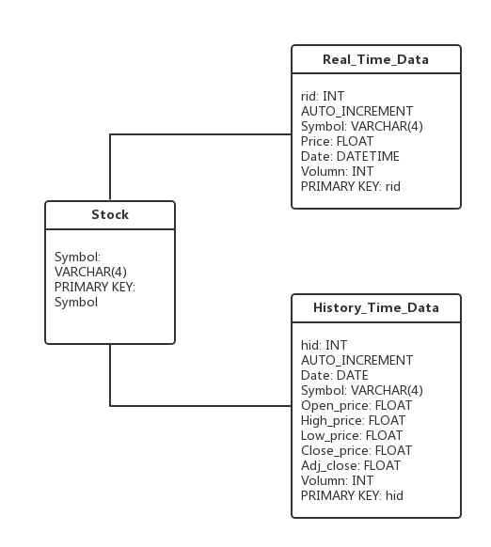

Figure Database Schema

In total, three tables are created to store data in database “stockDB”. Table “stock” stores the basic information of each stock, table “Real_Time_Data” stores the real time data for each stock, including symbol, close price, date(date and time) and volume, and table “History_Time_Data” stores the history time data, including date, symbol, open price, high price, low price, close price, adjusted price and volume for each stock. “Symbol” in table “Real_Time_Data” and “History_Time_Data” are the foreign keys which reference to “symbol” in table “stock”.

SQL:

CREATE DATABASE stockDB;

CREATE TABLE stock(

symbol VARCHAR(4) NOT NULL,

PRIMARY KEY(symbol));

CREATE TABLE Real_Time_Data(

rid INT UNSIGNED AUTO_INCREMENT NOT NULL,

symbol VARCHAR(4) NOT NULL,

stock_date DATE,

stock_time TIME,

price FLOAT,

volume INT,

PRIMARY KEY(rid),

FOREIGN KEY(symbol)

REFERENCES stock(symbol)

ON DELETE CASCADE

);

CREATE TABLE History_Time_Data(

hid INT UNSIGNED AUTO_INCREMENT NOT NULL,

symbol VARCHAR(4) NOT NULL,

stock_date DATE,

open_price FLOAT,

high_price FLOAT,

low_price FLOAT,

close_price FLOAT,

volume INT,

PRIMARY KEY(hid),

FOREIGN KEY(symbol)

REFERENCES stock(symbol)

ON DELETE CASCADE

);